Archi

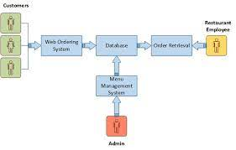

<https://itsourcecode.com/uml/online-food-ordering-system-uml-diagrams/>